Sociology
- Study of society
- How groups interact
- Based on observation

Social Sciences related to Sociology
- Psychology -- individuals
- Economics -- commercial exchange behavior
- Anthropology -- pre-literate societies
- Political science -- government and law
- History -- social relations in the past

Nature vs. Nurture

Genetic basis of behavior (Biological differences)
Behavior derived from the genetic material, this is the stuff of instinct. Nearly everyone is in agreement that very little of human behavior is instinctive. There are certainly genetically based predispositions (e.g., irritability, shyness and so on) as well as physiological differences.

Social basis of behavior (Sociological differences)
Virtually all of human behavior is learned. Speech, how we relate to one another, roles, what is important to us, our beliefs, our religion, our conception of god, of nature, of ourselves. All is learned from other humans.

Culture
The beliefs, values and expectations that guide our behavior. A culture consists of institutions that set up ways to behave in certain realms (e.g., the family, the economy, the education and so on). In addition culture includes the technology.

Components of culture

Symbols:
Anything that stands for something else in a culture (such as the national flag, specific animals, colors, etc).

Language:
Standard system of written or spoken symbols (like a spoken language, a computer or machine programming language, or body and facial gestures).

Values:
Shared beliefs about good and bad. The general ideas we share - about what is good or bad, right or wrong, desirable or undesirable - that transcend particular situations or interactions. Important to note that values are beliefs or ideas - not specific actions.

Norms:
  - Shared rules of conduct in a culture. These (rules that govern our behavior in specific situations) can be quite informal (rules about how we dress, stand when talking to others, how we address one another) to formalized laws. Three major categories of norms include:
    - Folkways (common customs or traditions)
    - Mores (morally significant norms)
    - Laws (written rules of conduct)

Importance of culture
- Sets behavior standards for a given setting
- Defines the structure of relationships
- Defines importance of setting, relationships, things (VALUES)
- Defines who we are and what we hold to be true (BELIEFS)

Elements of the experimental method
The experimental method involves the use of a control group and an experimental group. Participants are randomly assigned to one or the other group. Both groups are observed before and after the application of the experimental variable or condition. The experimental group is exposed to the experimental variable or condition. The control group is NOT exposed to the experimental variable. A comparison is made of the treatment of the experimental group with the control group to see if it (the experimental treatment) had any effect. If the differences before and after treatment in the experimental group are greater than the differences between the before and after differences in the control group, then we conclude that the treatment had an effect.

Elements of the survey
The survey is today a very widely used way to collect information about a society at a particular time. You see the results of such surveys almost everyday in the news reports. Whenever a newspaper or TV anchor says, "today's poll shows..." s/he is relying upon a survey. These kinds of surveys are done to describe what the population is thinking. However, sociologists, economists, political scientists and other social scientists use surveys to collect data about people so that hypotheses can be tested.

Culture: My understanding of how to "get" it
As part of teaching culture, I begin with this "lecture reading" along with the graphic showing the relationship among the four key concepts to understanding any culture/group. As I work with my kids in understanding the connections and interrelations among these concepts, they learn a more complete view of cultural understanding.
To me, it is impossible to understand culture without examining these concepts together.
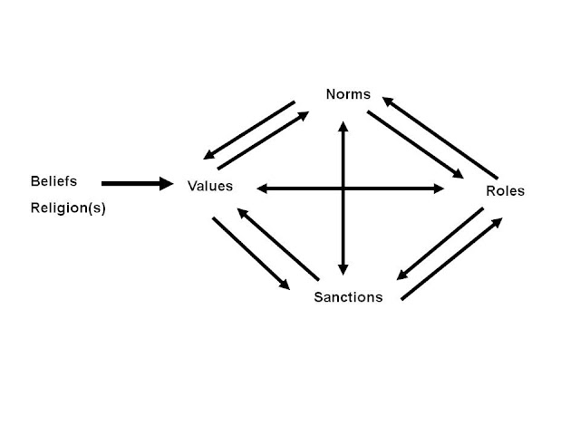

Values, Norms, Roles and Sanctions Lecture

Values are important aspects of a culture that a group feels are either desirable or undesirable. These standards are shared criteria for distinguishing good from bad, acceptable from unacceptable. Values are not something that can be decided by scientific experiment, but rather are matters of collective preference. Many values are connected with intense sensations of attraction or repulsion, approval or disapproval, which we have learned to feel about them.
Values have the following qualities:
A. Chosen freely
B. Chosen among alternatives
C. Chosen after thoughtful consideration of the consequences of each alternative
D. Prized and cherished
E. Publicly affirmed
F. Acted upon
G. Consistently acted upon

If one knows the values of a culture, one can make certain predictions concerning the way its members will behave. Values are the link between beliefs and the rules of a culture, called norms.
Norms are shared rules of conduct, directing what should and should not be done by certain individuals under certain specified conditions. It is through norms that values are put into action. There are two kinds of norms. Folkways, which are connected to daily behavior for what to do, customs and fashions, the violation of which will not produce a major problem. However, a more (pronounced moor-ay) is a norm, that when broken, will produce a strong public outrage. Examples of these include rape, incest, murder, etc.
Norms are very closely related to roles, which are the parts we play in society. In our daily lives, we are putting on different masks, all of which reflect a part of us. Some look upon this as "posing," but it is really a just a way to cope with the changing demands of a variety of situations. Each role is built up from many norms. Therefore, norms can be thought of as the building blocks of roles. Each part we play has a series of expectations or norms. As a student, you have a part to play with many expectations associated with it. These expectations can be considered norms or rules for how you should and shouldn't behave.
To enforce norms, cultures and other groups create sanctions, rewards or punishments that are designed to keep deviant behavior at a minimum. They may range from a harsh look or a hug, to the silent treatment, incarceration, or even the end of life. It will depend on the norm broken, the role of the person, and the value that was threatened.
The Cultural Universals

Cultural Universals are the key elements shared by all groups of people throughout the history of man. Studying these elements helps us to understand how and why groups of people live together as they do.
The cultural universals help to explain why cultures differ in different times and places.
What are the cultural universals?
1. Place and Time
  - Location: the land, climate
  - Time: When did the people live?
  - How the people looked; a physical description
2. Family Life
  - Roles of males, females, children and elders
  - Division of labor: Who does what work?
  - Family gatherings and marriage ceremonies
  - Child training and "rites of passage"
3. Economics
  - Existing technology: tools and weapons
  - Division of labor: How is the work divided?
  - Jobs: how people make a living
  - Trade and money
4. Food, Clothing, Shelter, and Transportation
  - Food: what they ate and how it was prepared
  - Clothes: everyday and special "ceremonial" wear
  - Dwellings: types of houses; building materials
  - Transportation: how people moved from place to place

5. Communication
  - Language: spoken, written, "sign" and "body" language
  - Number systems
6. Government
  - Rules and laws that govern the group
  - Who makes and enforces the rules and laws?
  - How do people resolve conflicts?
  - How is the government organized?
7. Arts and Recreation
  - Literature, music, art and dance
  - Use of leisure time
  - Games of children and adults
8. Belief Systems
  - Religious beliefs and practices
  - Birth and death rituals
  - Stories of creation
  - Myths: explaining the unknown
  - "Rights" and "wrongs" of behavior
  - What did the people value?
9. Education
  - Knowledge needed for survival
  - Knowledge valued by the group
  - How children learn their culture
  - Formal training
  - Informal training

